Works – 4 – Altre vite (Other lives)

Tizietto
2011
Epson print application plexiglass back with aluminum support
3 sets of 33 x 150 cm
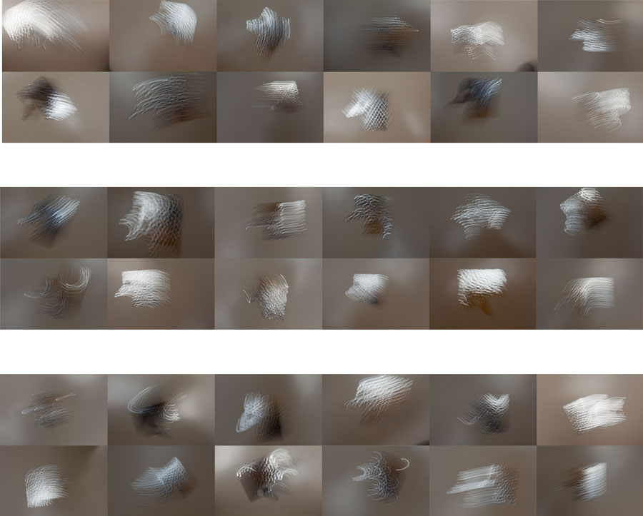

Regno artificiale. Oggetto n°1
(Artificial Kingdom. Object #1)
2011
Lambda print application plexiglass back with aluminum support
110 x 110 cm
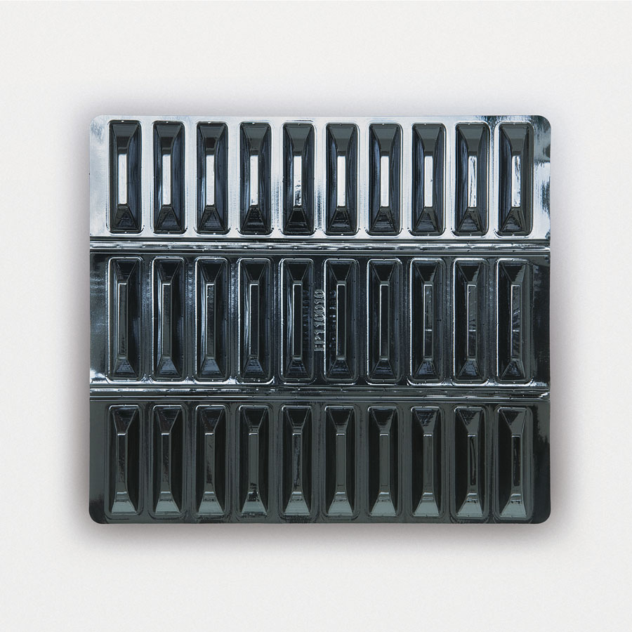

Regno artificiale. Oggetto n°2
(Artificial Kingdom. Object #2)
2011
Lambda print application plexiglass back with aluminum support
110 x 110 cm
